2024 Master's Thesis

Title of the Thesis

GRADUATE SCHOOL OF
INTERNATIONAL DEVELOPMENT
NAGOYA UNIVERSITY

Student Number:
Name:
Academic Advisor:

September, 2024
or
March, 2025
【修士論文用】
【For Master's thesis】

剽窃チェック確認書
Confirmation Form for Plagiarism Check

下記の提出論文について剽窃チェックソフト（Turnitin）を利用し、以下の結果を得ました。ここに盗用がないことを報告します。チェックした論文は最終版であり、事務へ提出する論文と同一です。

The following is the result of checking plagiarism in my thesis using Turnitin. I hereby confirm that there is no plagiarism. The checked document is the last version and is the same with the thesis to submit to the GSID office.

チェックした日
Date of Check

提出論文タイトル
Title of Thesis

類似率  Similarity Rate | %
類似率が15％を超える場合の理由及びその他
Reasons for Turnitin similarity rate higher than 15% and others

注意 Turnitinに論文の本文のみのファイルをアップロードすること。本様式を修士論文の2ページ目とすること。

Note: Upload a file of the body of the thesis onto the Turnitin. This form should be the second page of the Master’s thesis.

Checklist for Master's Thesis Submission
In submitting the thesis, I hereby confirm the following items and that the thesis meets the guidelines for submission as specified by the Graduate School.
Items to check | Check by the Applicant✓
（1）The format of the title
・The case of English paper follows the capitalization rules.
・Subtitle shall be as follows.
In the case of English paper, separate them with ":" (one-byte character-colon).
In the case of Japanese paper, separate them with "―" (two-byte character-dash).
（2）Cover
・A cover should include 20XX Master’s Thesis, the title of the thesis, Graduate School, student ID number, name, and academic advisor’s name.
・The year "20XX Master's Thesis" at the top should be the year of the academic calendar.
・September or March 20XX at the bottom should be the expected year and month of completion, not the academic year
・The name should exactly match the name verified on the Diploma Details Confirmation Form.
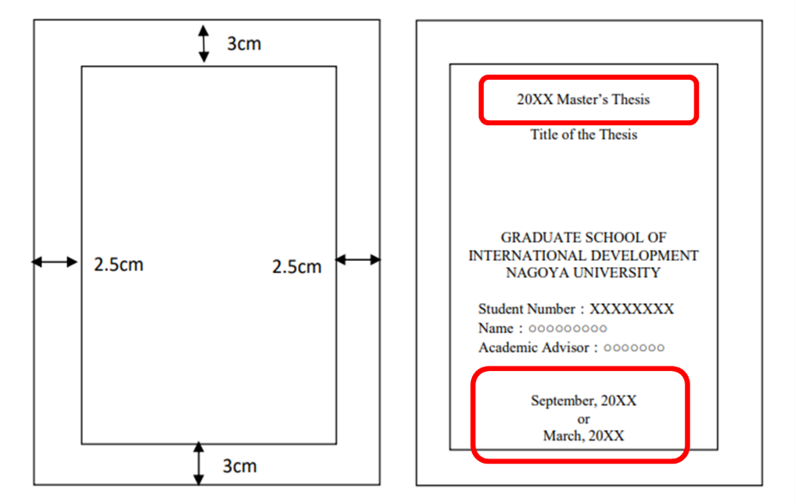
（3）Layout and format
・A PDF file of your Master’s thesis has every page from the beginning to the end. Page numbers are placed at the bottom (center) of pages.
・The file includes all the appendices such as endnotes and bibliography, if any.
（4）Submission to TACT
・PDF
・The file shall be uploaded to the designated location on TACT.
・Obtain final approval from the academic advisor before submitting the master's thesis to TACT.
This form should be the third page of the master's thesis.

The following should be given in the order of summary of the thesis, followed by the main body of the thesis.
If you have any questions, please follow the instructions of your academic advisor.

